1. 測試內容:

測試Flow之match field: “TCP_SRC”、“TCP_DST”是否正確運行

1. 測試環境架構:

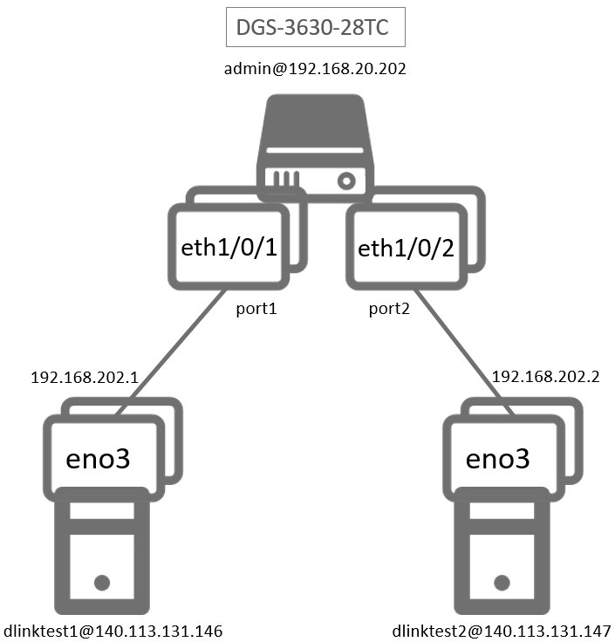

1. 測試環境組態

* SDN controller: ONOS 1.15.0
* Switch: DGS-3630
* Hosts:
* ubuntu 16.04.5 LTS
* dlinktest1(實體機)
  + - IP : 192.168.202.1
    - MAC : d0:94:66:5d:5e:08
    - Port : 1
* dlinktest2(實體機)
  + - IP : 192.168.202.2
    - MAC : d0:94:66:5c:45:20
    - Port : 2
* Apps:

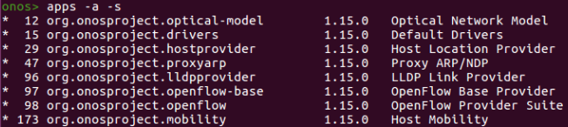

1. 使用之JSON文件

* Flow rule: (附檔: flow_tcp.json)

“ETH_TYPE”、“IP_PROTO”是“TCP_SRC”、“TCP_DST”必要前置欄位。且利用“IN_PORT”區分dlinktest1→dlinktest2與dlinktest2→dlinktest1的封包。

|  |
| --- |
| {  "flows":  [  {  "priority":40001,  "timeout":0,  "isPermanent":true,  "deviceId":"of:000078321bdf4000",  "treatment":{  "instructions":[  {  "type":"OUTPUT",  "port":"2"  }  ]  },  "selector":{  "criteria":[  {  "type":"ETH_TYPE",  "ethType":"0x0800"  },  {  "type":"IP_PROTO",  "protocol":6  },  {  "type":"IN_PORT",  "port":"1"  },  {  "type":"TCP_SRC",  "tcpPort":5001  }  ]  }  },  {  "priority":40002,  "timeout":0,  "isPermanent":true,  "deviceId":"of:000078321bdf4000",  "treatment":{  "instructions":[  {  "type":"OUTPUT",  "port":"1"  }  ]  },  "selector":{  "criteria":[  {  "type":"ETH_TYPE",  "ethType":"0x0800"  },  {  "type":"IP_PROTO",  "protocol":6  },  {  "type":"IN_PORT",  "port":"2"  },  {  "type":"TCP_DST",  "tcpPort":"5001"  }  ]  }  }  ]  } |

1. 測試步驟
2. ONOS GUI: Flow View

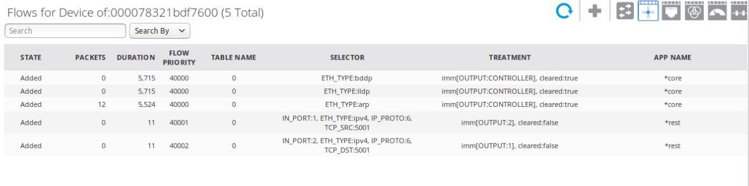

1. Monitor: Using iperf tool
   * dlinktest1 as the client sending TCP traffic.



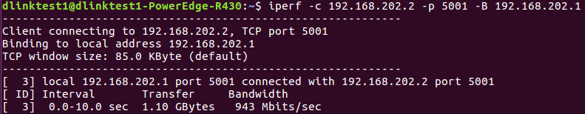

* dlinktest2 as the server receiving TCP traffic from h1.



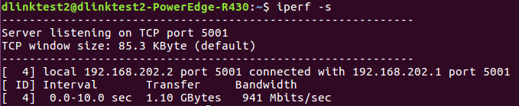

* dlinktest2 uses tcpdump to monitor.



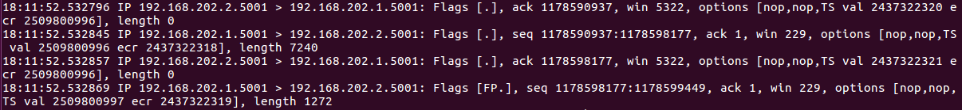

1. 測試結果

Flow之match field: “TCP_SRC”、 “TCP_DST”正常運行